ACTIVITY REPORT
Attendance:
___3____ members
___3____ non-members
___3____ staff
___1____ invited guests
Organiser : UTAR Yoga Society & Mr Fernando
Activity Name : Intro to Russian Martial Art Systema
Date : 09 August 2025 (Saturday)__________________________________________
Time : 10:00 am – 12:40 pm__________________________________________
Venue : KB Block 9 Floor Concourse Area, Sungai Long Campus.

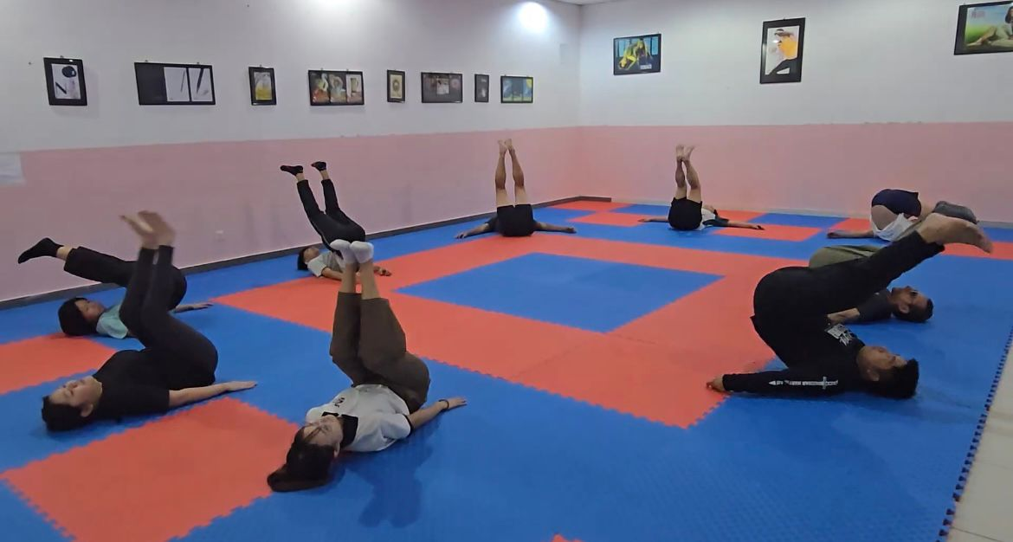
Participants enjoying the session in KB Level 9 Concourse Area, Sungai Long Campus

Executive Summary
On 9 August 2025 (Saturday), UTAR Yoga Society in collaboration with Mr. Fernando Paulo da Costa Andrade (LKCFES-DASD) successfully organised an event titled “Intro to Russian Martial Art Systema” at the Sungai Long Campus. The session introduced participants to the fundamentals of Systema, a martial art that emphasises breathing, relaxation, posture, and movement rather than aggressive combat. Led by Mr. Fernando, Systema Instructor-in-training / UTAR lecturer, and guest Systema Instructor Mr. Takeshi (Singapore), the workshop provided participants with both physical training and practical self-awareness techniques. The event was attended by 10 participants, including Yoga Society members, non-members, university staff, and invited guests.

Overview of the Activity
The day began at 9:30 AM with participant check-in, followed by the opening Systema Fitness session at 10:00 AM. This session warmed up the body through breathing-based exercises, mobility work, and relaxation drills, laying the foundation for the martial art practice to follow. At 11:10 AM, the main session on Systema Martial Arts commenced, lasting approximately 1.5 hours. The training focused on the four key pillars of Systema — breathing, relaxation, posture, and movement — all delivered in an approachable way for beginners.
The instructors explained that Systema is different from other martial arts such as Taekwondo or Karate, as it does not emphasise rigid techniques or aggressive sparring. Instead, participants were guided to explore how the body naturally moves under stress, and how soft, efficient movements can be used to neutralise threats or protect oneself calmly.
The session was enhanced by the presence of Dr. Yong Mun Ching, who served as the official event photographer, capturing key moments of the training and participants’ experiences.

Progress of the Activity
The activity was well-structured and smoothly run. Mr. Fernando led the warm-up and introductory practices, while Mr. Takeshi, the guest instructor, provided deeper insights into Systema principles, sharing his experience in applying the art to real-life contexts. Participants actively engaged in the drills, working in pairs or small groups to practise relaxation techniques, controlled breathing under pressure, and defensive movement.
Although the second session was scheduled for 1.5 hours, everyone was so immersed in the training that time seemed to pass unnoticed. The practice continued until nearly 1:00 PM, and only then did participants realise the session had gone beyond the planned schedule — a reflection of how enjoyable and engaging the experience was. The environment was open, relaxed, and encouraging — which matched the core philosophy of Systema itself.

Outcomes of the Activity
The event achieved its main objective of introducing participants to Systema in a practical and enjoyable way. Participants reported gaining not only physical insights but also a deeper appreciation for how breathing and relaxation affect their ability to respond to challenges.
As one of the participants, I personally found the session eye-opening. Unlike other martial arts such as Taekwondo that emphasise sparring or competition, Systema focuses on self-protection through soft, fluid movements. The training reminded me that proper breathing is essential not just in martial arts but also in everyday life, especially in managing stress. I learned that Systema is less about fighting and more about maintaining calmness, awareness, and resilience in difficult situations.
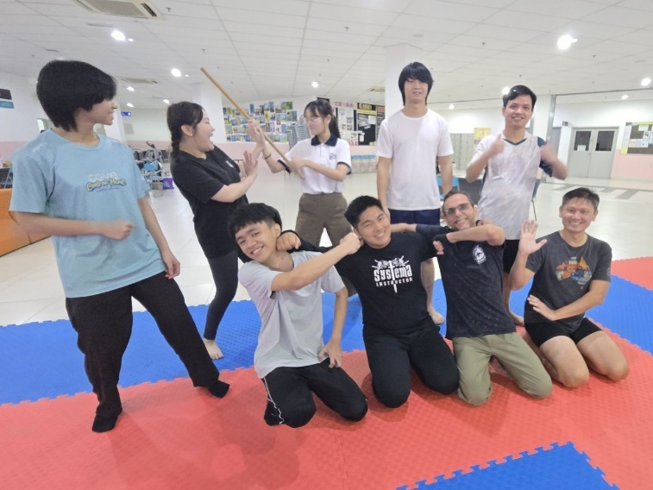
All the participants having a lot of fun after the session

Participants’ Feedback
The positive response from participants was very encouraging. A few reflections include:
- “The breathing techniques were simple but powerful. I realised how much calmer and more focused I became even in just a short practice.”
- “Systema is unlike any martial art I’ve tried before. It’s not about fighting to win but about moving naturally and protecting yourself wisely.”
- “I enjoyed the friendly and open environment. The instructors made the class easy to follow, even for complete beginners like me.”
- “This was a refreshing experience. I left the session feeling more relaxed in both body and mind.”
- “I really liked how the emphasis was on softness and awareness, not aggression. It’s a martial art I would love to continue exploring.”

Conclusion
The “Intro to Russian Martial Art Systema” event was a meaningful and successful collaboration between UTAR Yoga Society and Mr. Fernando Andrade, with valuable contributions from guest instructor Mr. Takeshi and photography support by Dr. Yong Mun Ching. Although the event had a modest attendance of 10 participants, the quality of instruction, depth of engagement, and positive feedback showed that it was highly impactful.
The activity successfully achieved its purpose: to introduce Systema as a unique martial art that prioritises breathing, relaxation, posture, and movement over competition and aggression. Participants were so absorbed in the training that the second session, originally planned for 1.5 hours, extended until almost 1:00 PM without anyone realising how much time had passed — a clear sign of how enjoyable and engaging the event truly was.
In conclusion, the event can be considered a success, and UTAR Yoga Society looks forward to organising similar workshops in the future that expand students’ understanding of wellness, self-protection, and holistic personal development.

Reported by:
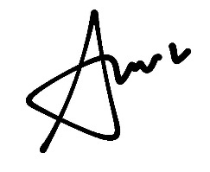
___________________________ _________________________ ______________________
Vivian Tang Yen Ai
Auditor, Yoga Society Designation Date: 19 August 2025

